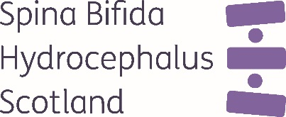

Key Responsibilities

To be as unstoppable as the people we support

- Deliver specialist clinical advice on continence, mobility, wound care, and other condition-related needs.
- Conduct online health assessments and develop personalised care plans.
- Liaise with multidisciplinary teams to ensure coordinated care.
- Support self-management strategies and promote independence.

To be a team player who unifies people around our cause.
- Organise and deliver workshops or webinars on health topics.
- Provide education and training to professionals, individuals, families, and carers on managing spina bifida and hydrocephalus.
- Act as a point of contact for health-related queries.
- Advocate for patients’ needs within healthcare systems and community services.
- Work closely with clinicians and communications colleagues to ensure our health information is authoritative and engaging for adults.
- Support research and service development initiatives.

A commitment to continuous learning and improvement.
- Maintain accurate records in line with GDPR and clinical governance standards.
- Regularly use data to report on the progress and impact of the service and identify areas for improvement.
- Undertake reflective practice.

Person Specification – Adult Health & Wellbeing Practitioner

 | Essential | Desirable
Qualifications/ Education | - Healthcare professional with current registration with an appropriate regulatory body. | - Evidence of Continuing Professional Development [CPD] in neurodisability, continence care, spina bifida, hydrocephalus, or self-management.
Experience | - Demonstrable & recent post registration experience.  - Experience in neurodisability, community nursing, or long-term condition management. | - Familiarity with quality improvement methodology and practice.
Knowledge and Skills | - Strong communication and interpersonal skills.  - Ability to work independently and as part of a multidisciplinary team.  - Knowledge of safeguarding and clinical governance.
Personal Qualities | - Compassionate and empathetic approach.  - Highly organised and proactive.  - Commitment to improving quality of life for individuals with complex needs.  - Approach issues with curiosity.

